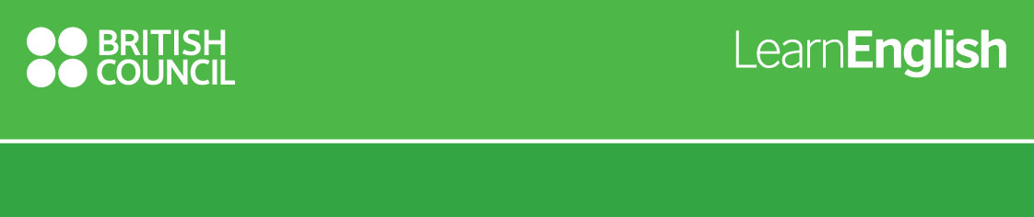**Quiz “English is Great”**

Q1: Where can you save money and have access to affordable low cost loans except bank in UK?

1. Loans house
2. Credit Unions
3. Citizens bureau

Q2: What does word “screenager” mean?

1. Young person or a teenager who spends a lot of time in front of computer
2. Somebody who is socially inept
3. Videogame designer

Q3: How should CV look like?

1. Short, simple, relevant
2. Detailed, more than 3 pages
3. Should contain a photo

Q4: When did the “Coventry City” football team win FA Cup?

1. 2001
2. 2012
3. 1987

Q5: How should regret letters to candidates look like?

1. Should be direct and straight
2. Should be polite and positive with feedback
3. Should be vague, without personalization

Q6: Where was Edward the Fourth imprisoned in 1400s?

1. The Buckingham Palace
2. The Kensington Palace
3. The Warwick Castle

Q7: Virgin Atlantic Airways were founded by….

1. Sir Richard Branson
2. Jurgen Weber
3. Sir Frederick Alfred Laker

Q8: Who has invented the bagless vacuum cleaner?

1. James Dyson
2. Tom Crawford
3. Duncan Bannantyne

Q9: What is the name of the world’s most famous motor sport venues in UK?

1. Wembley Stadium
2. Millenium Stadium
3. Silverstone Circuit

Q 10: What is the name of the Scotland's highest mountain?

A. [Ben Lawers](https://en.wikipedia.org/wiki/Ben_Lawers)

B. Ben Nevis

C. [Cairn Toul](https://en.wikipedia.org/wiki/Cairn_Toul)